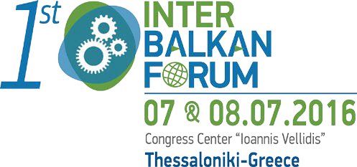

Promoting Regional Cooperation In the Food & Beverages Sector
PARTICIPATION FORM
NAME:
PROFESSION/CAPACITY:

BODY/COMPANY / INSTITUTION:

ADDRESS:
CITY/COUNTRY:
ΤEL. :
FAX:
E-MAIL:

Admission is free and there will be simultaneous translation English - Greek - English.
For information on the organization of the Forum, contact phone +30 2310 291213 or send an e- mail message at congresses@helexpo.gr

