Welcome to PROJECT Iran 2015

Important dates & times

We highly recommend that you print this page and keep it with you at all time during the buildup and break down of your stand

- Space only stand build-up 04 to 07 June 2015 09am till 10pm
- Fitted shell stand build-up 05 to 07 June 2015 09am till 10pm
- Outdoor stand build-up 04 to 07 June 2015 09am till 10pm
- Exhibition opening hours TBA TBA
- Exhibitor access 08 to 11 June 2015 TBA
- Visitor access 08 to 11 June 2015 TBA
- Limited break down 11 June 2015 TBA
- Break down 12 & 13 June 2015 TBA

Note:

- All stand construction & Stand Set Up must be completed by 08.00 pm on the 7th June 2015

- Failure to meet these deadlines may result in a penalty fees of 3,000.00 USD

- For all heavy machineries to be displayed inside the halls, it is a must to bring it inside the halls on the first day of the build-up

All Exhibitors and contractors are required to leave the venue at 23:00 on 7th June 2015. Security personnel will clear the site and there will be no re-entry after this time

Quick References list

This exhibitor manual has been designed to provide you with all the assistance and information you require leading up to the show. This does not replace our personal service; please contact us if you require any assistance

International Sales Organizers – IFP GROUP SAL
Mrs Francoise Nehme  Int’l Sales Manager | Tel: +961 5 959 111 Ext 133 | francoise.nehme@ifpexpo.com
 | Fax: +961 5 959 666 | francoise.nehme@ifpexpo.com

Official Stand Contractor – NPAPT
Ms. Zahra Ramezani | Tel: +98 21 88527578 |  |  | Z.ramezani@npapt.ir
 | Mobile:+98 912 2455605 |  |  | Z.ramezani@npapt.ir
Ms. Mahboobeh Mohseni | Tel: +98 21 88174934 |  |  | M.mohseni@npapt.ir
 | Mobile:+ 98 930 6222627 |  |  | M.mohseni@npapt.ir
Freight Forwarder Contact Details

ELITE ARIA JAM |  | Mr. Afshin akhbari | Afshin.akhbari@elitearia.com  Tel:+98 21 88516875 (Ext: 130)  Mobile: +98 912 5330751  Maryam.zarrineh@elitearia.com  Tel: +98 21 88516875 (Ext: 106)  Mobile: +98 912 2481042
TRCL – Tehran Rakhsh Co. Ltd. |  | Ms. Tannaz Peykan | Tel.: +98-21-88 87 83 60 Ext.109  Fax: +98-21-88 87 83 66  To: Info@trcl.ir  cc: Exhibition@trcl.ir  cc: peykan@trcl.ir  cc: emrani@trcl.ir  cc: k.emrani@yahoo.com

Kindly complete the below forms and return to:

Mrs Francoise Nehme – Int’l Sales & Marketing Manager

e-mail: francoise.nehme@ifpexpo.com

Phone: +961 5 959 111 Ext 133

Order form summary

- Please complete the applicable order forms and return them as soon as possible to ensure a trouble free exhibition experience
- Deadline to Receive All Forms is 20th April 2015, all forms & orders received after this date will not be inserted in the show catalogue.
- Faxed, Scanned or hand written copies are not accepted. Only typed formats will be inserted in the catalogue

Order form 1: Show catalogue entry (Compulsory)

The information given below will appear in the official show catalogue and will be used as a reference by visitors in the future

Company Information
Company Name
Title (Mr. / Mrs., Eng. etc ...)
First Name
Last Name
Position (Project Manager, General Manager, Sales Manager, etc …)
Address
P.O. Box
City
Country
Telephone | +
Mobile | +
Fax | +
Email
Website
Twitter
Facebook

Brands – please list the brands your company represents (i.e. Siemens, ABB, Bosch, etc.)

Brand: | Brand:
Brand: | Brand:
Brand: | Brand:
Brand: | Brand:
Brand: | Brand:

Branches – please list the branches your company has in the country of origin or others

City: Country: | City: Country:
City: Country: | City: Country:
City: Country: | City: Country:
City: Country: | City: Country:
City: Country: | City: Country:
City: Country: | City: Country:

Company Profile:

Please select (x) any of the applicable profiles related to your company’s profile. If your profile is not listed below, please list them next to other (Compulsory)
 |  | abrasives & adhesives |  | air conditioners
 |  | airport equipment |  | alarm systems
 |  | aluminum |  | anticorrosion products
 |  | architectural finishes |  | asphalt / machinery
 |  | banking & financial services |  | bathrooms & fittings
 |  | cement products |  | construction tools & equipment
 |  | concrete |  | contracting & trading
 |  | consulting |  | doors & windows
 |  | cutting, polishing & handling equipment |  | environmental monitoring equipment
 |  | earthmoving equipment |  | false ceilings & ceiling material
 |  | elevators |  | floor coverings
 |  | facility management |  | furniture
 |  | fasteners |  | gypsum products
 |  | formworks |  | heavy machinery
 |  | glass & glazing |  | interior design / architecture
 |  | governmental bodies / associations |  | kitchens
 |  | heating systems |  | paints
 |  | home appliances |  | plastics
 |  | insulations |  | property management
 |  | iron & steel products |  | recycling technologies
 |  | landscaping products |  | road signs
 |  | machinery |  | refrigeration
 |  | metal processing |  | real estate
 |  | oil & gas |  | roofing systems
 |  | packing equipment |  | specialized presses
 |  | pipes & plumbing |  | specialized vehicles
 |  | plants |  | specialized services
 |  | pollution management |  | solid waste management
 |  | professional clothing |  | security equipment
 |  | pumps |  | sanitary ware / equipment
 |  | stainless steel |  | safety products
 |  | telecommunication equipment |  | scaffolding
 |  | transport, hoisting & materials |  | swimming pools
 |  | tents & shades |  | vehicles
 |  | wall coverings |  | trash collection
 |  | warehousing / freight forwarding |  | water filtration & purification systems
 |  | wood products |  | waterproofing
Others:

Green technology

 |  | Bamboo and straw |  | Coal combustion products
 |  | Lumber from forests |  | Foundry sand
 |  | Ecology blocks |  | Demolition debris in construction projects
 |  | Recycled metal |  | Carbon sinks
 |  | High and ultra-high performance, roman self-healing concrete
Others:

Energy / Power / Lighting

 |  | Air-Conditioning Systems |  | Batteries
 |  | Bulbes & Tubes |  | Commercial Lighting
 |  | Cable & Wiring |  | Distribution Networks
 |  | Diagnostic Equipment |  | Design & Consultancy
 |  | Electrical Engineering |  | Electrical Supplies
 |  | Generators |  | Gas Turbines
 |  | High Voltage Transmission |  | Hydro Power

 |  | Indoor Lighting |  | Insulation Material
 |  | LED Lighting |  | Lighting Accessories
 |  | Lighting & Fixtures |  | Motors
 |  | Monitoring & Control |  | Outdoor Lighting
 |  | Power Generation |  | Power Plant Equipment
 |  | Power Protection |  | Power Stations
 |  | Renewable Energy |  | Switchgear Products

 |  | Switches & Controls |  | Solar Energy
 |  | Specialized Clothing |  | Solar Energy Systems

 |  | Software (Energy, Lighting, Power) |  | Solar Renewable Energy Technologies
 |  | Transformers |  | Water Renewable Energy Technologies
 |  | Wind Energy |  | Wind Renewable Energy Technologies

Others:

Stone / Marble / Granite
 |  | Abrasives |  |  | Artistic Bronze Work
 |  | Chemical Products |  |  | CNC Machinery for Marble, Granite & Stone
 |  | Cutting, Quarry & Polishing Tools |  |  | Discs & Blades
 |  | Diamond Tools |  |  | Dimension stone
 |  | Engineered Stone, Marble Agglomerates |  |  | Granite
 |  | Granite Blocks & Slabs |  |  | Granite Bridge Saw
 |  | Grinding Machinery |  |  | Marble & Granite Tiles
 |  | Marble Blocks & Slabs |  |  | Marble Polishing & Protection Products
 |  | Marble |  |  | Mosaics
 |  | Multi-Function Milling & Cutting Machinery |  |  | Machines & Equipment for the Stone Industry
 |  | Machines & Systems for disposal, ecology & Treatment |  |  | Natural Stone
 |  | Numerical Control Machines |  |  | Polishing Machinery
 |  | Quartz |  |  | Quarrying, processing & installation equipment
 |  | Reconstituted Stone |  |  | Recycled stone
 |  | Slate – Roofing, lead |  |  | Stone
 |  | Stone Products |  |  | Stone Cleaning & Restoration
 |  | Stone Veneer |  |  | Stone Design
 |  | Transport & Hoisting Systems |  |  | Technologies for the recovery of the architectural heritage
 |  | Unfinished Stone, Large Format |  |  | Workshop Machinery & Equipment
Others:

Order form 2: Exhibitor badges (Compulsory)

Exhibitor name badges are pre-printed. Badges along with your exhibitor pack can be collected from the Organizers office On-site from 5 to 8 June 2015 between 08:00 – 20:00 daily
Please clearly type the name and position of your staff that will be present at your stand during the exhibition

Exhibitor Name | Position | Mobile | Telephone | Email Address

Company |  |  | Stand no
Completed by |  |  | Date
E-mail |  |  | Tel no

Order form 3: Invitations (Compulsory)

Invitations can be sent to all existing and potential clients inviting them to your stand and for the official opening ceremony. It is recommended to send the invitation(s) with a covering letter indicating the products you intend displaying, we will be providing you with an e-invite,

*** Please send me an e-invite (soft copy) to the below email address

Email Address:

Contact Name:

Order form 4: Fascia name board (Compulsory for Fitted Shell stand)

FASCIA: this is the sign with your company name which appears above your stand

- Please type the name of your company in the box below with a maximum of 26 characters. This should be in English only.
- If you require to print a logo / colored Name Board, please email the Contractors for a quotation

Company |  |  | Stand no
Completed by |  |  | Date
E-mail |  |  | Tel no

Order form 5: Electricity supply and lighting
(Compulsory for Space Only Stand)

Fitted shell may complete this form only if they require additional electricity and lighting

Company Name |  | Stand no
Contact Person |  | Tel. no
Address |  | E-Mail
Fax no. |  | Date
# | Power Mains, Audio Visual, Electrical Appliances and Fittings | Qty | Price / USD | Total / USD

Should you require 24 hour power or for the stand to be energized earlier, kindly contact the contractro for an additional quotation to support your requirements
Kindly submit your orders to M.mohseni@npapt.ir and Z.ramezani@npapt.ir

Order form 6: Furniture and Appliances (Optional)

Company Name |  | Stand no
Contact Person |  | Tel. no
Address |  | E-Mail
Fax no |  | Date
# | Furniture and Appliances | Qty | Price per sqm / per piece /USD |  | Total /USD
1 | Lounge Chair, Single Seat |  | $50.00
2 | Lounge Chair, Double Seat |  | $100.00
3 | Upright Chair |  | $20.00
4 | PlexiGlass Folding Chair |  | $25.00
5 | Leather Arm Chair |  | $30.00
6 | Bar Stool |  | $30.00
7 | Writing Table, 80*80cm |  | $30.00
8 | Writing Table, Glass 90cm Diameter |  | $45.00
9 | Information Counter (100*50*100) |  | $50.00
10 | Free Standing Lockable Cabinet (100*50*100) |  | $55.00
11 | Free Standing Counter |  | $50.00
12 | Free Standing Plinths (50*50*50) |  | $30.00
13 | Free Standing Plinths (50*50*75) |  | $35.00
14 | Free Standing Plinths (50*50*100) |  | $40.00
15 | Low Glass Showcase (100*50*100) |  | $75.00
16 | High Glass Showcase (100*50*200) |  | $150.00
17 | Wall Panel |  | $25.00
18 | Solid Lockable Door |  | $90.00
19 | Shelf (30*100) |  | $8.00
20 | Catalogue Holder |  | $45.00
21 | Carpet (Price Per 1 sqm) |  | $8.00
22 | Water Cooler / Heater |  | $110.00
23 | Refrigerator |  | $80.00
24 | 32’ LCD TV |  | $400.00
25 | 42’ LCD TV |  | $450.00
26 | DVD Player |  | $80.00
27 | Waste Basket |  | $4.00

Order form 6: Furniture and Appliances …… continued
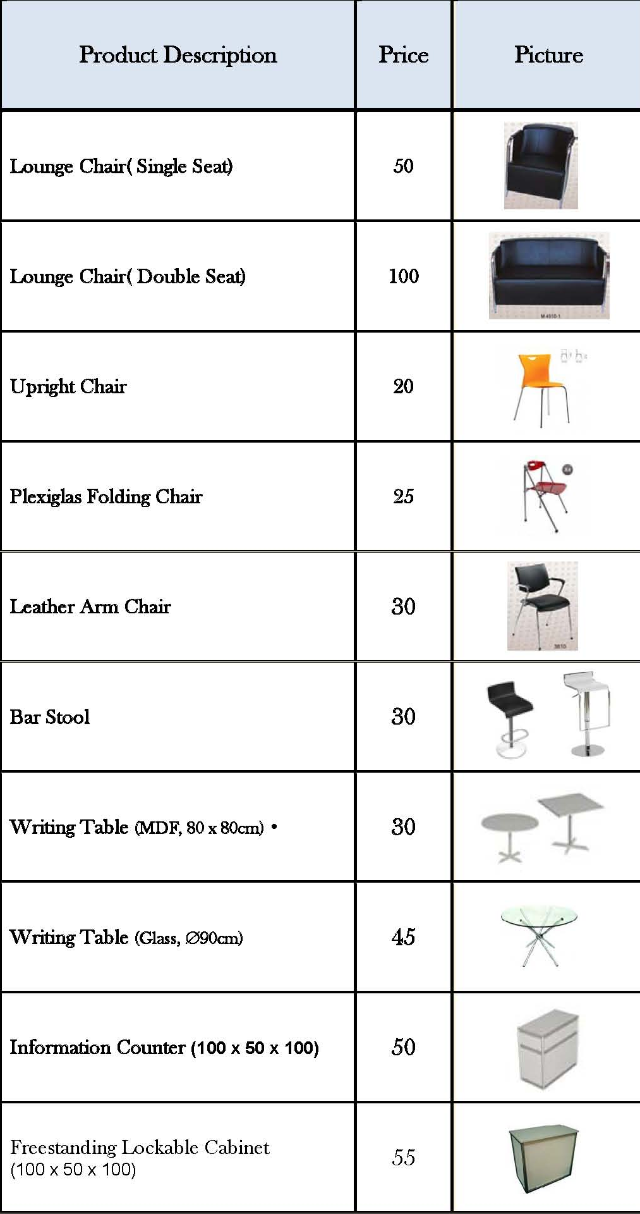

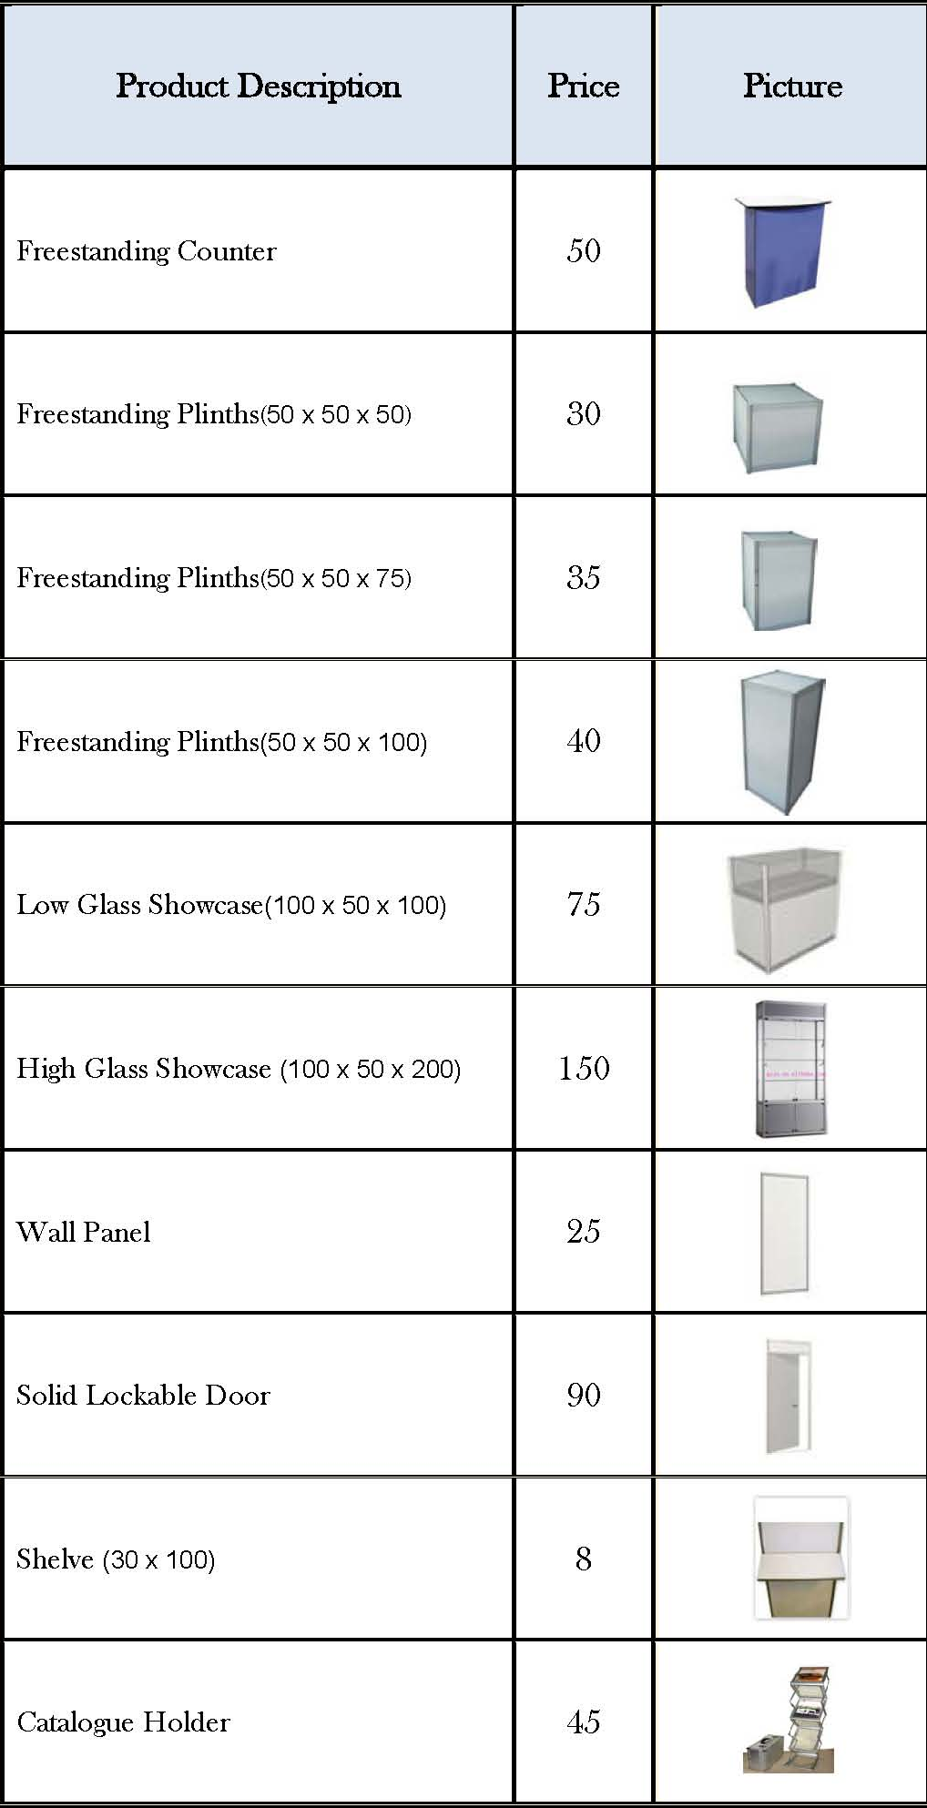

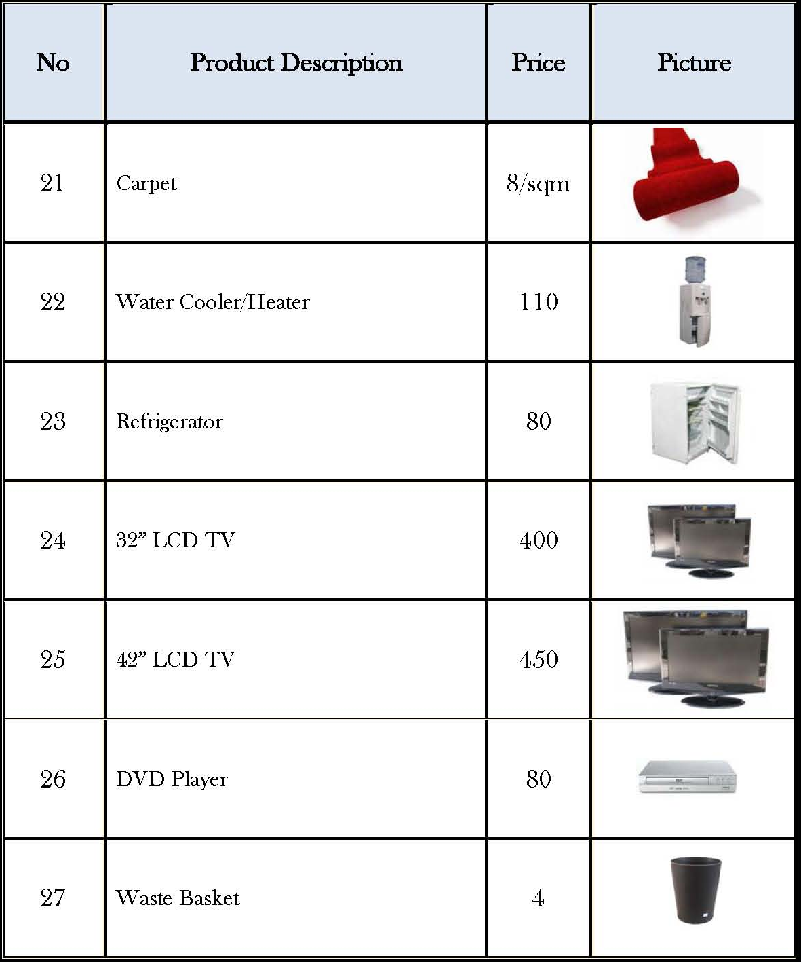

Order form 7: Company Logo (Optional)

If you wish to publish your company’s logo next to your company description in the show catalogue, kindly complete the below box and return to us with your logo as follows

Description | USD | QTY |  | Sub Total
Company Logo (2 Color i.e. Black & White) | 150.00
Company Logo (4 Color i.e. Colored Logo) | 250.00
TOTAL

The logo should be an EPS Vector File Format, either an Illustrator or Freehand File

Four Versions of the logo are required
- a Black and white EPS version
- a CMYK colored EPS version
- a Pantone colored EPS version
- a reversed out on black EPS version

Note that all these formats should be in high resolution EPS preferably vector files

Logos will NOT BE ACCEPTED unless full payment has been made before the 01 May 2015

Company |  |  | Stand no
Completed by |  |  | Date
E-mail |  |  | Tel no

Order form 8: Show catalogue advertising (Optional)
10,000 copies of the official show catalogue will be printed and distributed free of charge to all exhibitors, providing a complete guide of exhibitors, their products and services. The show catalogue is considered an up-to-date and a reliable buyer’s guide. Advertising in the official show catalogue is beneficial to your company, increasing exposure to visitors at the show and in the future

Description of Full Color Adverts |  | USD |  | QTY |  | Sub Total
A5 full page |  | 1,500.00
2x A5 double page |  | 2,500.00
bookmark |  | 5,500.00
250g insert |  | 4,500.00
Spine |  | 5,500.00
A5 inside front cover |  | 3,500.00
A5 inside back cover |  | 3,500.00
A5 outside back cover |  | 5,500.00
2x A5 front cover double page |  | 5,865.00
 |  |  |  | Total
Please note all cover pages are subject to availability
Technical specifications of advertising material
- A5 size (20.5cm height, 13.5cm width)
- 3mm bleed
- 300 dpi
- PDF or EPS format on CD (artwork to be attached)

Advertising booking and material deadline: 01st May 2015
Payment is due when booking your advertisement - orders will not be processed unless full payment is received

Payment for the above can be made by cheque or bank transfer to

Company |  |  | Stand no
Completed by |  |  | Date
E-mail |  |  | Tel no

Order form 9: Flowers and Plants (Optional)

Zaeem Flowers has been appointed as the official florist for the show, Kindly contact the below to place your order or to get a quotations

Mr. Zaeem
Web www.zaeemflowers.ca/En/FShop
Email sales@zaeemflowers.ca
Tel +98 21 82806989 or +98 21 82802335

Order form 10: Translators & Temporary Personnel (Optional)

Order form 11: Official Rent-A-Car

Europcar has been appointed as the Official Rent-A-Car partner for Project Iran 2015. We trust that they will offer you with the best discounted rates, facilities and service during the period of the show

To book your car kindly contact the below mentioned & a representative from the company will be in touch with you to accommodate your request

For enquiries please contact
Mahtab Habibi | Europcar IRAN | Senior Client Liaison
Office: +98 21 88366615|
Mobile: +98 912 545 63 23| www.europcar.ir
mahtab.habibi@europcar.ir



Order form 12: Hotel accommodation
The Organizers have pre-booked 250 hotel rooms in PARSIAN AZADI Hotel in Tehran which is the closest to the show and will have a daily shuttle bus to accommodate all exhibitors
To reserve your rooms, kindly complete the below and send it to Mrs. Francoise Nehme at francoise.nehme@ifpexpo.com to receive your confirmation.

PARSIAN AZADI HOTEL (5 Star)
Address: Yadegare-Imam Cross Road-Chamran Highway-Tehran-Iran. +9821-29112
W: www.azaditehran.pih.ir
P: +98 21 223 44444
F: +98 21 223 44478

HOTEL RATES
No. | Room Type | Rate Per Night
1. | Single Room (1 Guest) | $140.00 USD
2. | Double Room (2 Guests) | $200.00 USD
3 | Junior Suite (2 Guests) | $255.00 USD

*All above rates include Breakfast

HOTEL BOOKING FORM

name of guest | Room type | no of nights | check  in date | check out date

company |  | stand no
completed by |  | date
e-mail |  | tel no

Wishing you a successful show!

